How to use the Tool Touch Macro

Automatic tool setting is a powerful routine that will really improve the speed and accuracy of your CNC work.

Here’s how it works.

Configure Mach 2 to accept a digitize input on your inputs page, and set the correct input pin assignment for your digitizer. The digitizer can be NC or NO and can trigger the input signal “high” or “low”.

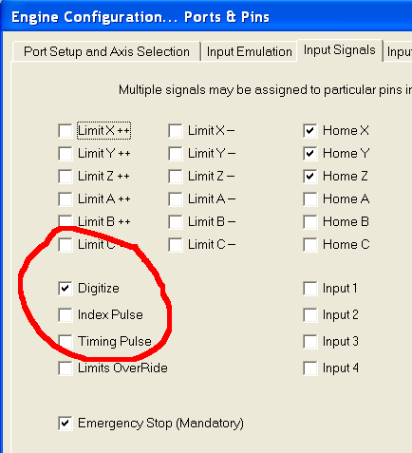

Your digitizer can be as simple as a NC electric switch or inductive proximity sensor, but for accurate and repeatable touch off (.001”) you will need a touch probe like the one shown in the photo. The touch probe sends an open circuit signal to Mach 2 whenever the contact is broken by your tool touching the switch.

This can also be accomplished by simply attaching a wire to your work and to the tool. When the two come together they will close the electric circuit and send the signal to the control. Be aware however that if you are doing this the tool must be electrically insulated from the work and this is not normal on most machine tools. Most machines will conduct electricity through the entire chassis of the machine. Also be aware that there is no “give” when your tool touches the work and any error in set up on your part will result in a broken tool or gouged work or both.

An inexpensive and reliable probe can be purchased from Minitech

Tool Touch Macro Explained

The VB code to execute your tool touch is shown below with a brief explanation of the functions shown in BLUE. Do not include the BLUE text in your code; it is simply an explanation of the function of the code.

This text can be written into a button using Mach 2 Screen Designer, or can be used to create a custom Macro function that can be executed a number of ways. Please consult Mach 2 documentation for more info on creating Macros or using Screen Designer.

Tool Touch Macro

REM Context 10001
if IsSuchSignal (22) Then

code "G49 g31 z-2 f10" Cancel any tool length offsets and move the tool to Z = -2.0 units at a feed rate of 10 units/time until a digitize signal is detected. Feed-rate is entirely up to you but make sure it’s not too fast or you will get inaccurate results from your digitize “touch”. You may want to set G90 or G91 on this line as well. The command will behave differently if you are in absolute or relative mode. G31 is a probing command that tells the machine to move in the commanded direction until a “digitize” input signal is detected.

While IsMoving()
Wend
Height = GetOEMDRO(85) Set the variable “height” equal to the value of the Z axis position DRO.

Call SetoemDRO(42,Height) Set the Z offset DRO to the value of the variable “height” This also sets the Z touch value in the Tool Table for the tool that you have selected. Be careful not to have tool “0” (zero) selected as this can cause some weird problems and the only way to clear tool zero back to zero offset is to move the machine to machine coordinates Z=0 and “touch”

Tool = GetSelectedTool ‘ this gets the current tool number
REM Context 10001
if IsSuchSignal (22) Then
code "G0X" & PROBEX & "Y" & PROBEY 'this moves us to above the switch
code "g31 z-10 f50"
While IsMoving()
Wend
MachineZ = GetVar( 2002 ) 'this is the point of switch contact
MachineZ = MachineZ - SPECIAL 'this calculates the length of the bit from bit 0’s length
code "G10 L2 P" & Tool &" Z"&MachineZ 'puts it in the tool table
code "G43H"&Tool ' and turns on the offset
end if

The SPECIAL is replaced by the distance of your Z from home to the top of the sensor with tool #0 in it. The macro subtracts the difference and know exactly how long the tool is
The G10L2 line sets the tool in the table and then turns on G43 with that tool. PROBEX an Y need to be changed to the XY position of the sensor on the table.

code "G49 G54 Z0" Cancel tool length offset and move the tool back to Z = 0. Depending on what mode you started in and how your Z axis is referenced this may not be where the tool started from.
While IsMoving()
Wend
end if

CAUTION - READ BELOW!!

1. All motion will be in the ABS or INC mode that you have selected (i.e. G90 or G91). For instance if the tool is at Z=-3 and you select “auto tool touch” the tool will actually move up which isn’t much good for tool setting. You may have to experiment with the G Code in your macro to get the machine to respond correctly for your application.

2. Make sure if you modify the code that you test all code before placing your probe under the tool. It is very easy to make a mistake here and actually have your tool crash into the probe and ruin it!! Please test all code safely before putting expensive components in the way of the tool. The combination of G91 and G90 plus the tool length offsets can create some confusing situations if you are not 100% familiar and experienced with how these codes affect your machine. Please read and understand the MACH2 documentation concerning tool length offsets, fixture offsets, and relative and absolute coordinate systems.

3. Be aware that if your Z axis has not been referenced you may experience some strange behavior when attempting your automatic tool touch off.

