Using Dolphin CAM Turning

Introduction
Dolphin CAM, DCAM, is a complete interactive, menu driven, programming environment and provides all the tools required to generate NC programs for a variety of machine tools, this document covers 2 and 2+2 axis turning machines. Geometry is automatically extracted from a Dolphin CAD drawing. Machining instructions for turning programs are entered by selecting from the menu. DCAM understands a wide variety of canned cycles including drill, ream, bore, and tap. Facing and turning cycles are all provided. It does not matter whether the target machine tool supports any canned cycle used in a DCAM program as the post processor can be directed to create NC programs using canned or expanded versions of any of the built in cycles.
To start the program, double click the DCAM icon on the desktop

Screen Layout
The DCAM screen layout is shown below. The main area of the screen is used for graphics output, to the right is a status panel showing the current tool position, feedrate, spindle speed and tool type and across the bottom is the menu, immediately below the menu is the message line.
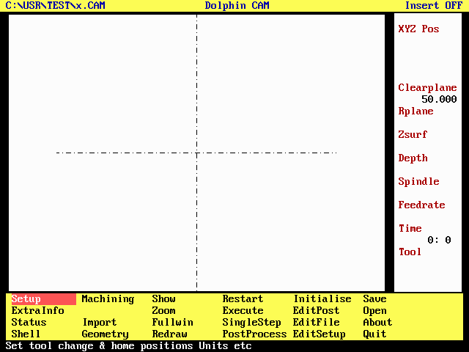Dolphin CAM screen layout

User Interface
Dolphin CAM application programs all share the same user interface. Options are presented in the form of menus, while additional information, which the programme may need in order to continue, is entered into a dialogue.

Menus
Within DCAM menus are displayed at the bottom of the screen, below the graphics area and above the message line. To select from the menu use the ←,,→ and ↓ arrow keys or the mouse to move the highlight to the selection you want, (The message line contains a brief description of each menu entry), and then press either the Enter↵ key or the mouse left-hand button.
There are in fact three menus, the main menu shown previously, and two sub-menus, one each for milling and turning. The sub-menu is accessed by selecting Machining from the main menu. To return to the main menu, select Return from any sub-menu, or press the Esc key. Pressing the Esc key while the main menu is displayed is the same as selecting the Quit option.

Dialogues
Once selection has been made from a menu, the program may need additional information before it can continue. In this case then a DIALOG screen is displayed in which that extra information can be entered.
Dialogues have one or more input fields in which data can be entered. One of the input fields is highlighted; this is the field currently expecting input. Use the mouse or the arrow keys to move the highlight to the field in which data is to be entered or changed, and then type in the new data from the keyboard. As each field is highlighted, the message line will contain a brief description of the data to be entered into that field.
Each dialogue will have buttons marked OK and CANCEL once satisfied that the information entered into the dialogue is correct, move the highlight to the button marked OK and press the ENTER key (or select the CANCEL button or press the ESC key in order to abandon the operation).
Each input field in a dialogue is designed to accept only one type of information, e.g. an integer or real number, a file or directory name, an arbitrary sequence of characters and so on. Pressing the help key will reveal exactly what sort of information is expected. (If the current input field expects a file or directory name then pressing the help key will reveal a MENU of available files or directories and you can select the one you want using the arrow keys or the mouse.)
It is possible to edit existing data within an input field in two ways.
1. Select the field using the arrow keys or the mouse, and then simply type in the new data. As soon as the first character of the new data has been entered, the whole of the existing data is erased to make way for it, press the Enter↵ key to move to the next input field.
2. Select the field as before and then press the INSERT key to reveal the text cursor. Use the arrow keys ← and → to move the cursor within the existing text, the DELETE or BACKSPACE keys to delete characters and the alpha numeric keys to add in new data. Once the data is correct press the ENTER key to move to the next input field.

The DCAM Main menu in brief
The main menu contains options for defining the type of machine tool to be programmed, for the importing of geometry from the Dolphin CAD system, for controlling the screen layout, invoking a post-processor and for reviewing any NC program created. Each option will be described briefly before being described in full
Set-up Machining Show Restart Initialise Save
ExtraInfo Zoom Execute EditPost Open
Status Import Fullwin SingleStep EditFile About
Shell Geometry Redraw PostProcess EditSetup Quit

Option | Description
About | Display Copyright notice containing version number and license details.
EditFile | Create, modify or view an NC program.
EditPost | Create, modify or view a post-processor.
EditSetup | Create, modify or view the "set-up sheet" created by the post-processor.
Execute | Simulate the complete NC program
ExtraInfo | Allows up to 6 lines of text to be sent to the post-processor as header information
Fullwin | Opposite of zoom. Display the full geometry.
Geometry | Invoke Dolphin CAD system.
Import | Import geometry from a DCAD drawing.
Initialise | Deletes the current job.
Machining | Invoke either the milling or turning sub-menu.
Open | Open an existing CAM file.
Post process | Create an NC program for a specific NC machine tool.
Quit | Exit the program.
Redraw | Re-paints the graphics display.
Restart | Same as a tape rewind on an NC controller.
Save | Save the current program to disk (as a .CAM file)
Setup | Define the target machine tool type
Shell | Execute MS-DOS commands without exiting from DCAM.
Show | Define viewpoint, and other screen parameters.
Single Step | Execute a single command in the NC program.
Status | Switches the status panel - at the right of the screen - on or off
Zoom | Magnify an area of the graphics display.

The DCAM Main menu in detail
Each item on the main menu will be described in full :-

Setup
Setup is used to inform DCAM about the component to be machined and the type of machine tool to be used, i.e.. A milling or turning machine.
On selecting Setup a series of 3 dialogues is presented :-
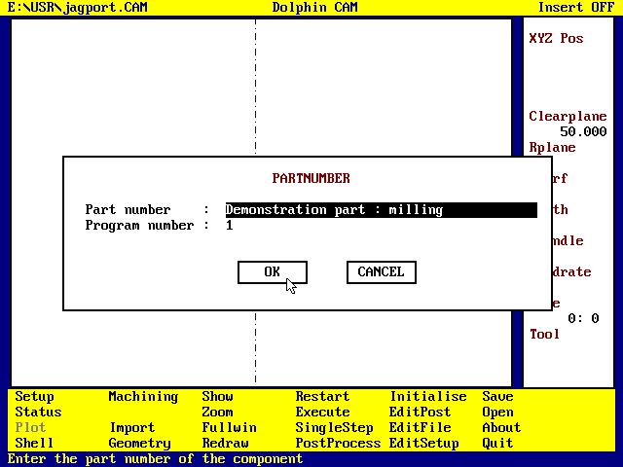
Entering Part number and Program number
The first dialogue is used to enter a part number and a program number, these may be left blank.
The part number identifies the component to be programmed, and may appear as a comment in the NC program.
The program number will be used to identify the program to the NC control system.
The second dialogue invoked by Setup is used to define the machine type i.e. a milling or a turning machine, and the programming units, millimetres or inches.
Once the machine type has been identified - by pointing to it with the mouse and pressing the left-hand button - the dialogue will erase unwanted entries in the Tool change position and Home position. These can then be entered together with the origin co-ordinates.
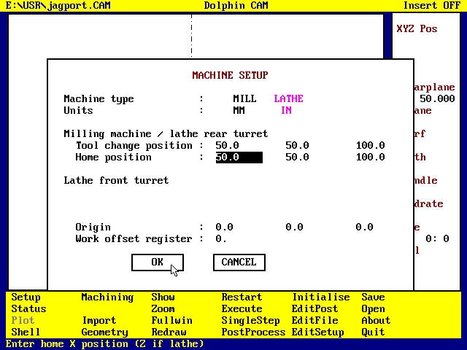Defining the machine tool setup and programming units
• For machine tools without automatic tool change or pre-set home positions these co-ordinates should be set to positions at which the operator can safely change tools and load/unload components.
• If the tool change / home position does not need to be programmed then the co-ordinates entered are used only for graphics purposes and will be ignored by the post processor.
• Dolphin CAM assumes that the tool is initially at the Home position. The Z value defined for the Home and Tool change positions must be greater than the Clear plane, which is defined, in the next dialogue.
• The origin is used to define the machine tool zero point relative to the geometry origin and will typically appear in a G92 block.
• The work offset register is typically used by the post processor to create a G54, G55,.. block. If set to 0, a G92 block is output instead. Offset register 1 = G54, 2 = G55 etc.
The third and final dialogue invoked by Setup is used to define the Clear plane, and the Feed change plane.
The clear plane defines a Z value above which the cutting tool may move in any direction without obstruction, i.e. it is higher than any point on the work piece and clamps, under normal circumstances DCAM will not execute any 3 axis moves below this plane.
The feed change plane defines the Z value at which feedrate switches from rapid to feed, it is often referred to as the R plane.
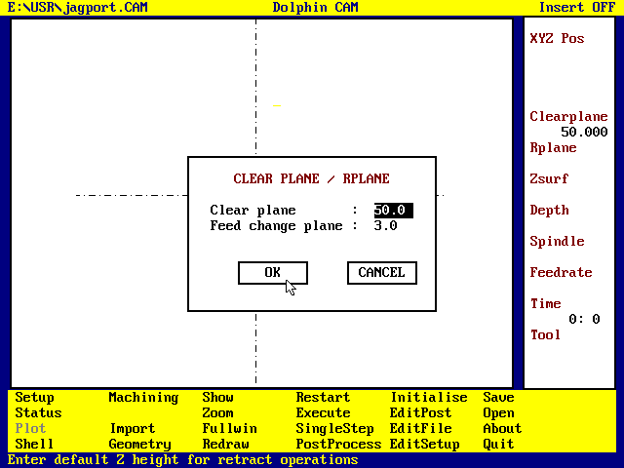Defining the Clear plane and Feed change plane

Status
Selecting Status switches the status panel OFF or ON. It has no effect on NC programming.

ExtraInfo
ExtraInfo presents a dialogue box in which the user can enter up to 6 lines of text. These have no effect on the program but are sent to the post-processor after the program number information and before any machining instructions. The postprocessor may ignore them or output them as comments in the NC program.

Shell
Selecting Shell temporarily exits the program to the DOS prompt, so that the user can enter DOS commands. To return to Dolphin CAM, type EXIT at the DOS prompt. If there is insufficient memory available, then the Shell command will not function.

Machining
Machining selects either the milling or turning sub-menu, these are described later. Machining cannot be selected until the Setup option has been used to define the machine type i.e.. Mill or Turn.

Import
Import is used to import geometry from a Dolphin CAD drawing; it is possible to combine geometry from more than one drawing. The list of drawings shown in the illustration below is obtained by pressing the F1 key or mouse right-hand button, while the File name field is highlighted.
In order to use the import function the drawing must contain suitable geometry definitions, which include: -
• Named points or groups of points - treated as co-ordinates for drilling operations
• Named circles - can be used by the Pocket command
• Contours and profiles - these define shapes to be produced by either milling or turning.
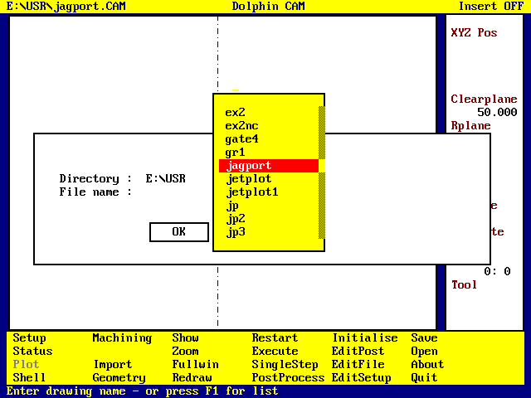Selecting a drawing to import geometry from
DCAM will scan the drawing file looking for CONTOURs and PROFILEs and will import the geometry they define. Contours are used to define the shapes of components to be milled while Profiles are used to define turned components. DCAM will also import any named CIRCLE or POINT that occurs within the drawing.
• If the geometry to be imported has been defined using a CAD system other than Dolphin CAD, then it must be exported from that system using AutoCad™ DXF format and imported into a Dolphin CAD drawing. Dolphin CAM cannot import DXF files directly.
• Use the COPY command in Dolphin CAD - sub-option C. create contour, or P. create profile - to create contours and profiles which can be imported into Dolphin CAM.
• Use the PNT command - sub-option P. create pattern - to create named points, which can be imported into Dolphin CAM.

Geometry
Selecting Geometry invokes the Dolphin CAD system - after first saving the current job. Use this to modify the geometry of the component to be produced. To return to DCAM select LINK from the CAD menu, the geometry already imported into the CAD file will be automatically replaced by the drawing geometry.
• If DCAM is invoked directly e.g. to modify an existing part program, a warning is issued if the drawing file has been modified more recently than the CAM file.
• When DCAM is invoked from within the Dolphin CAD system all suitable geometry is automatically imported by the CAM system.

Show
Show is used to define how tools and geometry will be drawn, together with the desired viewpoint. Use the mouse to select the desired options - by pointing and pressing the left-hand button.
• During graphical verification of a part program drawing the tool centreline only is very fast but may not allow the tool path to be immediately obvious.
• Drawing the tool geometry and envelope is most useful when checking an area clearance type operation.
• Animating the tool drawing allows the tool path to be followed quite easily but can take considerably longer especially on SX computers.
• Viewpoints other than XY are of little use for turned components.
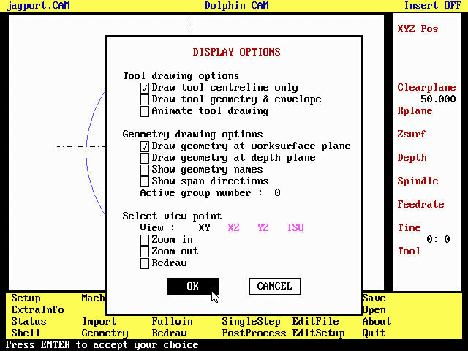Setting display options

Zoom
Select Zoom to magnify part of the graphical image. Use the mouse to indicate opposite corners of the area to be magnified.

Fullwin
Fullwin is the opposite of Zoom - i.e. zoom out. It redraws the screen so that the whole component can be seen. Each time Fullwin is selected the graphics are drawn at 50% of the previous size. Select Zoom followed by Fullwin to reset the graphics to normal size.

Redraw
Selecting Redraw causes DCAM to erase the screen and redraw the geometry. Any toolpath currently displayed is not redrawn. To re-display the tool path select Restart followed by Execute.
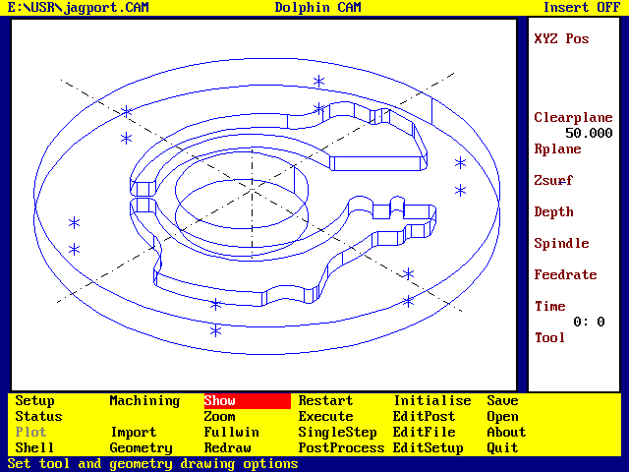Geometry displayed at Depth using ISO view

Restart
Restart is equivalent to rewinding the NC part program. To view the entire machining sequence select Restart followed by Execute.

Execute
Execute is equivalent to Cycle start on most controllers. It executes the part program from the current operation - usually the first - through to the end. Pressing the ESC key will cause a dialogue to be displayed asking if the program execution should be halted.

SingleStep
Each time SingleStep is selected DCAM will execute the current operation and make the next operation current. If the current operation is the last DCAM will display a list of all operations, allowing the user to select from the list the operation at which single stepping is to begin.
• Using SingleStep within the Dolphin CAM system is not equivalent to single stepping the machine tool controller since each operation within the cam system may eventually generate zero, one or maybe hundreds of blocks within the NC program.
- To achieve a single step similar to that on a machine tool, it is necessary to press ALT+F1. The tool will wait at the end of each move until the user presses any key. Pressing ALT+F1 again ends the single step sequence.

PostProcess
Select PostProcess to produce an NC program. Dolphin CAM does not produce anything that can be sent to a machine tool controller until PostProcess is selected, at which time the program is committed to a particular machine tool/controller.
The complete part program is executed and the tool path is translated into the specific format required by the machine tool controller.
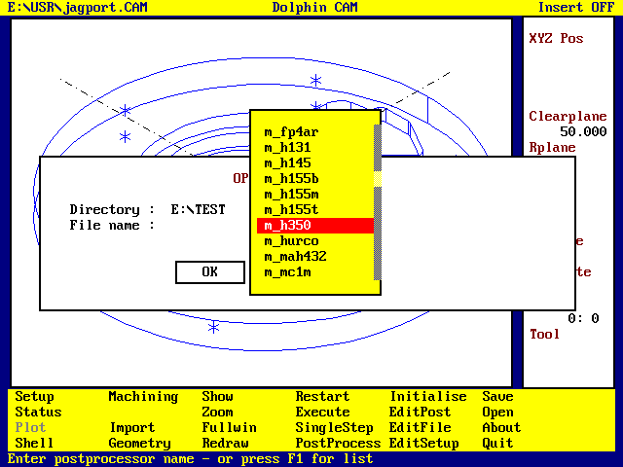Selecting a post-processor
Selecting PostProcess reveals a dialogue in which to enter the name (and directory) of the post processor. In the example M_H350 is about to be selected, this is a post-processor for a machine equipped with a HeidenHain 350 controller.
• Pressing the F1 key or the mouse right-hand button while the mouse points to the File name field will cause a scrolling list of all available post-processors to be displayed. Selection can then be made using the mouse or arrow keys.
• The file selected contains information specific to the target machine tool and it's controller. These files are plain ASCII text files with a .PPR extension and normally reside in the directory C:\DOLPHIN.
• Post processor files whose name starts M or M_ are for milling machines, T or T_ are for turning machines and W or W_ are for wire erosion machines.

Initialise
Select Initialise to delete either all the geometry, all the machining instructions or both, from the current program. Initialising both geometry and machining is equivalent to restarting Dolphin CAM from scratch.

EditPost
EditPost invokes the Dolphin CAM text editor and loads the current post-processor file into the editor workspace. If the post-processor file is modified by the editor then the user can save it under the original filename, or create a new post-processor file.
• The post processor is described later in this manual.
• The DCAM text editor is a simple full screen editor in which most keys represent themselves. It has two operating modes - Insert ON - in which characters typed are inserted into the existing text and - Insert OFF - in which characters typed replace the existing text.
- The keys Insert, Delete, Home, End ←, , →, ↓, PageUp and PageDown do what is expected of them. The text cursor can be positioned by pressing the lefthand mouse button when the mouse is pointing at the desired position.
- Press F1, or the mouse righthand button, to obtain a list of other command keys.
• To exit the DCAM text editor press the ESC key. If the file has been changed by the editor, DCAM will ask if the new version should be saved.

EditFile
EditFile invokes the Dolphin CAM text editor and loads the NC program - jobname.PUN - into the editor workspace. The user can then view the post-processed output, this is the file that will ultimately be sent to the machine tool.

EditSetup
EditSetup invokes the Dolphin CAM text editor and loads the file jobname.TLF (if it exists) into the editor workspace. This file, which is created by the CAM system rather than the post-processor contains brief details of the job being programmed, together with a list of the tools used by the program.

Save
Selecting Save causes Dolphin CAM to save the current job to disk. It is stored in a file with a .CAD extension. The file format is a binary one and the file cannot be edited except by the Dolphin CAM system.

Open
Selecting Open loads an existing DCAM work file into memory after saving and discarding the current work file. This allows the user to work on several NC programs in a single session.

About
About displays the Dolphin CAM copyright notice and version number. It also displays the program serial number and licensed user name.

Quit
Selecting Quit terminates the Dolphin CAM session after first saving the current job.

Dolphin CAM - Turning
Dolphin CAM turning is designed to support twin turret lathes where the two turrets are independent of each other and may or may not be capable of simultaneous working. Once the Setup command has been used to specify Home and Tool change positions for each turret, selecting the Machining command will reveal the turning sub-menu.

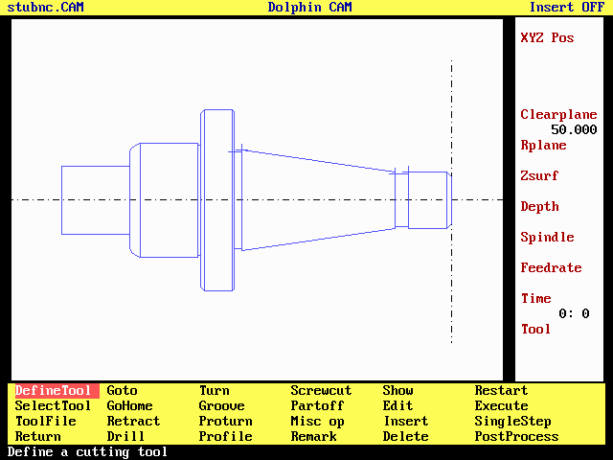
DCAM showing a Turned Component

The Turning sub-menu
DefineTool Goto Turn Screwcut Show Restart
SelectTool Gohome Groove Partoff Edit Execute
Toolfile Retract Proturn Misc Op Insert SingleStep
Return Drill Profile Remark Delete PostProcess
This menu contains all of Dolphin CAM's commands for producing and modifying NC programs for CNC turning centres. Some of them - Show, Restart, Execute, SingleStep and PostProcess, have already been described as they also appear on the main menu. The remainder will be described below.
Option | Description
DefineTool | Define a tool, retrieve a tool from the toolfile database.
SelectTool | Make a previously defined tool active, set feeds and speeds.
Toolfile | Attach to a toolfile, delete a tool from the toolfile database
Return | Return to the main menu.
Goto | Drive tool a specific ZX co-ordinate
Gohome | Send tool to home position
Retract | Move tool in Z axis to Clear plane
Drill | Single point canned cycles
Turn | Turning or facing area clearance routines
Groove | Machine a groove or Trepan
Proturn | Finish turn a component
Profile | Define component geometry
Screwcut | Machine a thread using a screw cutting canned cycle
Partoff | Partoff the finished component
MiscOp | A collection of miscellaneous operations
Remark | Insert a remark into the NC program
Show | Define tool drawing and view options
Edit | Modify an existing command
Insert | Insert a new command into the program
Delete | Delete a command from the program
Restart | Rewind the program.
Execute | Simulate the NC program
SingleStep | Simulate the NC program command by command
Post Process | Convert the DCAD turning program into an NC program for a specific machine tool.

DefineTool
Before any machining instructions can be entered, at least one tool must be defined. Selecting DefineTool from the menu reveals the tool definition dialogue - shown below.
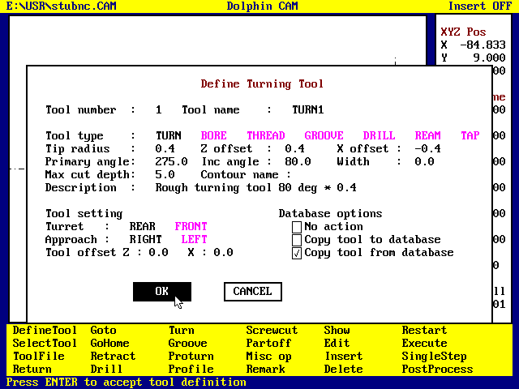
Defining a Turning tool
The first thing to be entered into this dialogue is the tool number. Typically this is the number that will appear in the tool change block in the NC program. Dolphin CAM supports a maximum of 40 tools, the post-processor may modify tool numbers to distinguish between tools on the front and rear turrets of a twin turret lathe.
Four basic tool types are provided TURN, BORE, THREAD, and GROOVE for turning work plus DRILL, REAM and TAP, which are tools which can only be used on the lathe's centre-line.
Tool type | Description
TURN | general purpose turning tool for external work.
BORE | general purpose turning tool for internal work.
THREAD | thread cutting tool for internal or external work.
GROOVE | plunge cutting, form tools, and partoff tools.
DRILL | any drilling tool - used with drill canned cycle only.
REAM | any reamer, - used with ream canned cycle.
TAP | any tap – used with tap canned cycle.
Use the mouse to select the desired tool type. The dialogue will offer default values for the tool dimensions based on the tool type selected. These dimensions refer to the tool tip geometry, and are described in the diagrams below, they are also used to draw a stylised graphic representing the tool. It is important that these dimensions are entered accurately as they can affect the tool path generated by the post processor.

Defining a Turning tool
For turning tools Dolphin CAM needs five dimensions, these dimensions are calculated when the tool datum point. is at Z0X0, they are :-
Dimension | Description | Default
Tip Radius | The radius of the tool tip. | 0.4mm
Z tip offset | The distance from Z zero to the centre of the tip radius. | 0.4mm
X tip offset | The distance from X zero to the centre of the tip radius. | -0.4mm
Primary angle | The angle measured positive anticlockwise from the Z axis to the primary cutting edge. | 275°
Included angle | The angle measured positive anticlockwise from the primary cutting edge to the secondary cutting edge. | 80°

Turning tool definitions
When defining a tool it does not matter whether it is to be mounted on the front or rear turret. Dolphin CAM assumes that the tool dimensions apply to a front mounted tool, as shown above, and adjusts them accordingly if the tool is mounted on the rear turret.

Defining a Boring tool
For boring tools Dolphin CAM needs five dimensions, these dimensions are calculated when the tool datum point is at Z0X0, they are :-
Dimension | Description | Default
Tip Radius | The radius of the tool tip. | 0.4mm
Z tip offset | The distance from Z zero to the centre of the tip radius. | 0.4mm
X tip offset | The distance from X zero to the centre of the tip radius. | 0.4mm
Primary angle | The angle measured positive anticlockwise from the Z axis to the primary cutting edge. | 85°
Included angle | The angle measured positive anticlockwise from the primary cutting edge to the secondary cutting edge. | -80°

Defining Boring Tools
When defining a tool it does not matter whether it is to be mounted on the front or rear turret. Dolphin CAM assumes that the tool dimensions apply to a front mounted tool, and adjusts them accordingly if the tool is mounted on the rear turret.

Defining Symmetrical tools
For symmetrical tools, such as threading tools, Dolphin CAM needs five dimensions, these dimensions are calculated when the tool datum point is at Z0X0, they are :-
Dimension | Description
Tip Radius | The radius of the tool tip.
Z tip offset | The distance from Z zero to the centre of the tip radius.
X tip offset | The distance from X zero to the centre of the tip radius.
Primary angle | The angle measured positive anticlockwise from the Z axis to the primary cutting edge.
Included angle | The angle measured positive anticlockwise from the primary cutting edge to the secondary cutting edge.

Defining Symmetrical tools

Defining Plunge cutting tools
For GROOVE type tools, such as partoff blades, Dolphin CAM needs six dimensions, these dimensions are calculated when the tool datum point is at Z0X0, they are :-
Dimension | Description
Tip Radius | The radius of the tool tip. Usually set to a small value - say 0.05mm
Z tip offset | The distance from Z zero to the centre of the tip radius.
X tip offset | The distance from X zero to the centre of the tip radius.
Primary angle | The angle measured positive anticlockwise from the Z axis to the primary cutting edge.
Included angle | The angle measured positive anticlockwise from the primary cutting edge to the secondary cutting edge.
Width | The width of a partoff blade or grooving tool.

Defining Plunge cutting tools

Tool Setting
In addition to the tool tip geometry, Dolphin CAM needs to know how the tool will be mounted on the lathe, and on which turret. Any tool may be set on either front or rear turret. The post processor knows which tool is on which turret and can adjust the tool numbers to suit. Typically tools 1 - 10 might be defined on the front turret and tools 11 - 20 defined on the rear turret.
Tools may also be set as either Right hand or Left hand approach, i.e. they cut from Right to left or from Left to right along the Z axis.
Irrespective of how tools are to be mounted on the turret, and whether they be mounted on a front or a rear turret, the tool should be defined as if it is mounted on the front turret, right hand approach as shown in the previous diagrams.
If the target lathe requires co-ordinate data referred to some datum other than the tool datum, e.g. a turret datum point, then the Z and X tool offsets must be entered into the DefineTool dialogue. The tool offsets are the distances in Z and X from the tool datum, to the turret datum. For lathes with two turrets mounted on a single cross slide, this feature can be used to refer all tools on both turrets to a single datum point. On lathes that expect the tool datum co-ordinates together with Z and X tool offsets, the offset registers are programmed in the SelectTool dialogue.
As well as producing either diameter or radius values for X axis, the post-processor can be instructed to output tool path co-ordinates in three ways :-
• The tool datum co-ordinates.
• The tool centre co-ordinates, i.e. the tool path co-ordinates are adjusted by the Tip offset values.
• The turret datum co-ordinates, i.e. the tool path co-ordinates are adjusted by the Tool offset values.

Tooling Database
Normally Dolphin CAM uses the tool tip dimensions to draw a stylised graphic to represent the tool. It is possible using the toolfile database to produce accurate scale views of the tool in order to improve the graphical verification of the tool path, and to provide improved visual collision checking.
In order to achieve this the Dolphin CAD system is used to draw a plan view of the tool. This geometry is then imported into the CAM system and associated with a tool definition. Any tool defined with associated geometry to represent it graphically can then be stored in the toolfile database, and retrieved later for use on other jobs.
To store a tool in the toolfile database, it must be given a unique name in the Tool name field, and the name of its associated geometry must be entered into the Contour name field, finally tick the check box Copy tool to database and select the OK button.
To retrieve a tool from the database, enter its unique name into the Tool name field, click the Copy tool from database check box, and select the OK button.
To list the tools stored in the database select the Tool name field and press the mouse right-hand button or the F1 key. A scrolling list of all tools stored in the database will be displayed on screen, and selection can be made using the mouse and the left hand button or the and ↓ arrow keys and the Enter↵ key.

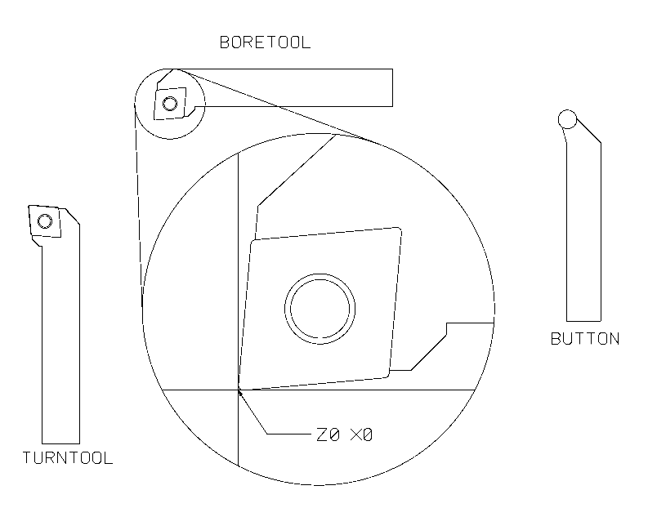Drawing tools for use by the toolfile Database

When drawing geometry to represent tooling it is important that when the geometry is traced (using the COPY command, sub-option C. create contour) the drawing origin is moved to the datum point of the tool, so that the contour origin and tool datum point are coincident.

SelectTool
Defining a tool does not produce any output in the NC program, nor initiate a tool change. In order to do this SelectTool must be used.
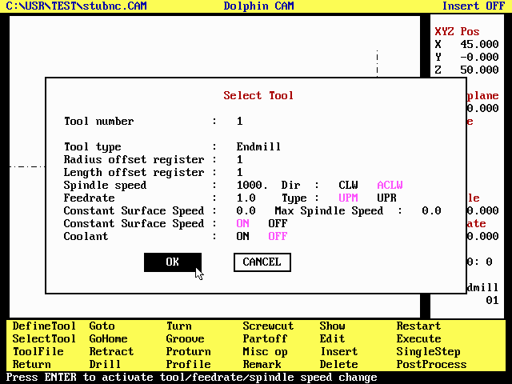Using SelectTool to change tools and set Speed & Feedrate
The SelectTool dialogue is also used to set the spindle speed and direction, the cutting feedrate and to switch coolant ON or OFF. A tool change sequence is initiated only if the tool number entered is different to the currently selected tool, otherwise only the new spindle speed, feedrate and coolant settings are sent to the post-processor.
Two feedrate types are supported :-
Feed type | Description
UPM | Units per minute - mm/minute or inches per minute
UPR | Units per revolution - mm/rev or inches per rev. For taps this is the pitch multiplied by the number of starts. (Threading operations define their own feedrate)
Irrespective of how the feedrate is programmed the post-processor can output either feedrate type where appropriate, i.e. when drilling, reaming, tapping or boring.
Either feedrate type can be used with Constant Spindle Speed, or with Constant Surface Speed by specifying the surface speed (meters/min or feet/min according to the programme units), maximum spindle speed r.p.m. and selecting Constant Surface Speed ON.
Coolant control can be exercised through this dialogue or it can be implemented automatically within the post processor. Coolant is automatically switched off and a spindle stop command issued before a tool change sequence. It is only necessary to switch coolant on if desired.

Goto
The Goto command is used to move the tool tip to a specific ZX co-ordinate, or by an incremental amount in any or all axes, either at feedrate or in rapid motion.

Gohome
The Gohome command is used to send the cutting tool to its Home position. i.e. the position defined in the Setup dialogue. Front and rear turrets may be homed individually. The move is executed by first moving the tool at rapid to the Z value defined as the Clear plane, and then in two axes to the Home position.
Moving the tool to the Home position.
A GoHome command can "home" either the tool mounted on the from turret or that mounted on the rear turret, or both at the same time. Its principal use would be to get one turret and its tooling out of the way while working with the other.

Retract
The Retract command is used to retract the tool - at rapid feedrate - to the Z axis value defined in the Setup dialogue [default], or to any Z value between the feed change plane and the clear plane. Normally Dolphin CAM will retract the tool to the feed change plane at the end of a drilling operation, and leave the tool at cutting depth - unless told not to - for most other operations.

Drill
All single point canned cycles are accessed via Drill. That is drill, drill dwell, peck drill, ream, bore, tap etc. It does not matter whether or not the target machine tool controller supports any or all of these canned cycles as the post-processor can output them to the NC program file either in canned cycle format or in expanded format. In this respect Dolphin CAM can enhance the capabilities especially of older machines since it is practical to use any desired canned cycle, not just those supported by the control system.
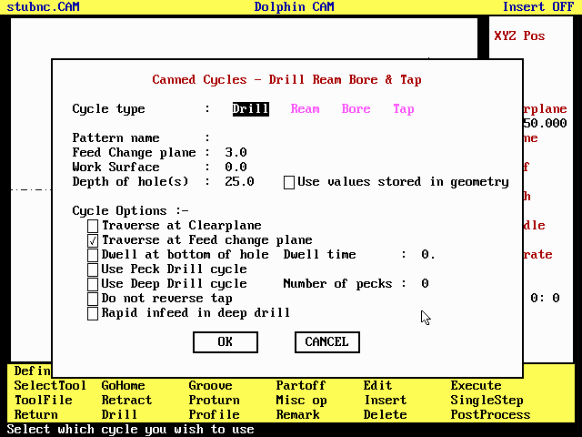
Defining canned cycles using the Drill dialogue
It is not necessary to enter a Pattern name in the dialogue as DCAM knows that drilling can only take place on the machine tool's centre-line. (DCAM does not support live tooling or C axis on turning machines). It is only necessary to enter the depth of the hole to be drilled.
DCAM supports four basic cycles.
Cycle type | Description
Drill | Feed to depth, retract at rapid. - Can be used with tools defined as either MILL or DRILL
Ream | Feed to depth, retract at feedrate. Can only be used with REAMers
Bore | Feed to depth, spindle stop, retract at feedrate, spindle start. Can only be used with DRILL tools.
Tap | Feed to depth, reverse spindle, retract at feedrate, reverse spindle. Can only be used with TAPs

The following options can be used with all canned cycles :-
Option | Description
Traverse at clearplane | The tool is retracted to the Clearplane Z value
Traverse at feedplane | The tool is retracted only as far as the feed change plane.

The remaining options are specific to either drilling or tapping :-
Option | Description
Dwell at depth | Use drill with dwell canned cycle, the dwell time must also be entered in the dialogue.
Peckdrill | Drill hole in a series of pecks retracting tool slightly - 3mm- between each peck, the number of pecks is entered in the dialogue. Each peck increases the hole depth by the same amount, unless modified by the post-processor. Prevents excessively long spirals of swarf by interrupting the cutting process.
Deep drill | Drill hole in a series of pecks, retracting tool completely between each peck. This has the effect of removing swarf from the hole.
No Reverse | Do not reverse tap when retracting. Tap holder reverses automatically.
Rapid infeed | Used only in deep drill, if the cycle is expanded by the postprocessor the tool will feed in at rapid on 2nd. and subsequent pecks.

Any of these canned cycles may be used whether or not they are implemented in the machine tool control system. If they are not, the post-processor can output an expanded version of the cycle.
If the post processor outputs canned cycles to the NC program file, then the exact behaviour of the machine tool is defined by its controller and not by Dolphin CAM.

Turn
Turn is a general purpose turning, facing and boring command used for area clearance. Selecting it brings up the Turn dialogue show below :-
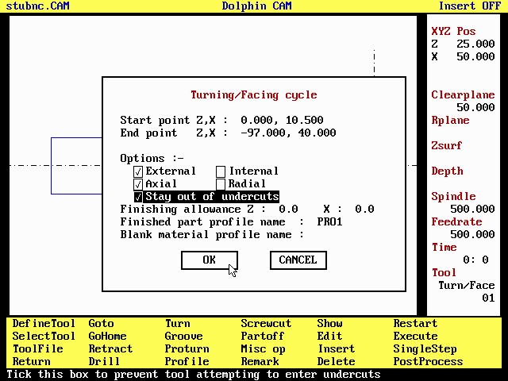
Defining a Turning Cycle
The Turn cycle operates between the limits defined by the Start point Z,X co-ordinates and the End point Z,X co-ordinates. These co-ordinates are opposing ends of either diagonal of the rectangular area defining the limits of the cycle.
The co-ordinates may be typed in directly or entered using the screen cursor. To enter co-ordinates using the cursor, use the mouse to select either the Start point field or the End point field and press the mouse Right hand button or the F1 key. The dialogue box will disappear temporarily, use the mouse to steer the cursor to the desired point and press the either the lefthand button to select the nearest span end point, or, the righthand button to select the coordinate of the mouse cursor.
Once the limits of the cycle have been defined use the remaining options in the dialogue box to define exactly how the cycle will operate :-
- External, tick this box to create an external turning or facing cycle, using a tool of type TURN. This cycle turns from the outside towards the centreline.
- Internal, Tick this box to create a boring cycle, using a tool of type BORE. This cycle turns from somewhere near the centreline towards the outside.
- Axial, Tick this box to create a turning cycle.
- Radial, Tick this box to create a facing cycle.
- Stay out of undercuts, Normally DCAM will attempt to machine as much as the tool geometry will permit. Tick this box to prevent the tool from attempting to enter undercuts.
Finishing allowance is used in conjunction with the Finished part profile. If a profile name is entered into this field it is assumed to define the finished part profile, and the cycle will be modified so that it does not cut into the finished part plus finishing allowance. The component can then be finish turned using the Proturn command.
Finishing allowances are specified separately for Z and X axes.
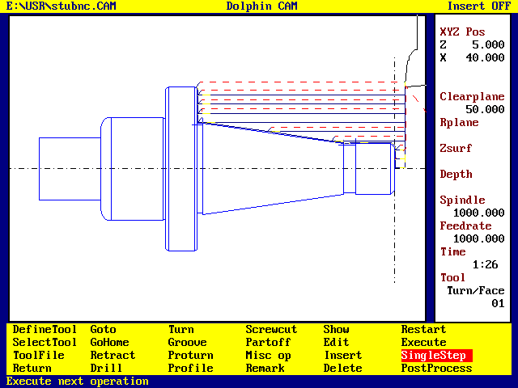Toolpath generated by a Turn cycle
If a profile name is entered into the Finished part profile name field, DCAM converts the turning / facing cycle into a stock removal cycle which will machine only as far as the finished part profile (plus finishing any allowance).
If a profile name is entered into the Blank Material profile field, it is assumed to define the raw material or billet profile. In this case the start and end co-ordinates are ignored and the cycle will operate between the blank material profile and the finished part profile, eliminating fresh air moves. This can be particularly useful when turning a casting or forging rather than from bar stock.

Groove
The Groove command is used for producing groove and trepanning cycles. The currently selected tool must have been defined as a GROOVE tool. The groove cycle is machined between the co-ordinates defined in the Start point and End point fields. The co-ordinates may be entered directly, or by using the cursor.
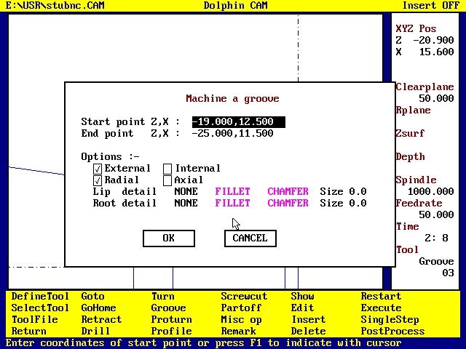
Defining a Groove canned cycle
Groove supports a number of options to modify how the cycle works :-
- External The groove is to be machined in an external surface on a diameter or a face
- Internal The groove will be machined inside a bore. It is the users responsibility to get the tool to a suitable starting point.
- Radial The groove is machined by plunging the tool radially, to depth at increments along the component axis, equal to or less than the tool's width.
- Axial The groove is machined by plunging the tool axially to depth at radial increments equal to or less than the width of the current tool. I.e. this transforms the Groove operation to a trepanning operation.
Lip detail and Root detail
The groove may be finished with either a fillet or a chamfer at the lip and at the root of the groove. If a root fillet or chamfer is specified, the groove is cut undersize initially and a final cut is taken down each side of the groove and the fillet/chamfer machined. It is not possible to specify fillets or chamfers on only one side of the groove. The width of the tool must be narrower than the groove less the width of the root chamfer/fillet - if any.

Proturn
The Proturn command generates turning of the named profile, and is generally used to finish turn a component after the bulk of the material has been removed using the Turn command.
The direction of machining, and the offset used by Proturn is determined automatically from the tool tip geometry.
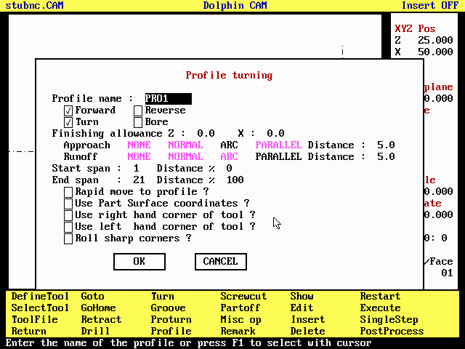
Defining a Finish turn operation
There are a number of options which can be used to modify the basic Proturn command :-
- Forward, tick this box to machine with the tool moving in the normal (forward) direction.
- Reverse Ticking the Reverse check box will cause the tool to move backwards around the component profile.
- Turn, If the current tool is of type TURN the tick the Turn check box to machine the profile as an external feature.
- Bore, If the current tool is a boring tool then ticking the Bore check box will cause the profile to be machined as an internal feature.
Finishing allowance is used to specify the amount of material to be left on for a finishing cut. Specify a negative value to machine the component undersize or a positive value to machine the component oversize. Finishing allowances are specified separately for Z and X axes.
Approach determines how the tool will attach to the shape to be machined.
Runoff determines how the tool will depart from the shape to be machined. Each has four options :-
Approach / Runoff | Description
NONE | No approach / runoff
NORMAL | The tool attaches to (approach) or departs from (runoff) the profile along a line at right angles first span (approach), or the last span (runoff), to be machined, the length of this line is specified as the approach / runoff distance.  Cutter compensation (G41 / G42) is applied on the approach move and switched off on the runoff move.
ARC | The tool attaches to the profile using a straight line and an arc, which is tangential to the first span. The line starts at a point which is given by the approach distance along a line at right angles to the first span.  The Runoff move is the reverse of the approach move, it consists of an arc followed by a short straight line.
PARALLEL | The approach / runoff move is made by extending the first / last span to be machined by an amount equal to the approach / runoff distance specified.
Start Span & End Span
Each profile is made up of a number of spans (lines or arcs) and they are numbered in the direction in which the profile was defined. Span 1 is the first, span 2 is the second and so on. When a profile name is entered in the dialogue, Dolphin CAM reads the profile definition to count the number of spans it contains and enters that number in the End Span field. The Start span always defaults to 1. By changing the numbers in the start / end span fields it is possible to machine any part of the profile.
It is also possible to machine only part of a span. To begin machining at a point midway along a span, enter its Span number in the Start span field and the percentage distance along the span at which machining is to start or stop. Use the Show menu command to display span numbers.
Dolphin CAM uses the tool tip geometry to determine whether or not it can machine the profile as commanded. If the current tool is of type TURN then it will not attempt to enter or machine any part of the profile which it considers to define a bore. Similarly if the current tool is of type BORE then it will not attempt to machine any part of the profile which it considers to define an external surface.
If the current tool is a GROOVEing tool then the user must specify which corner of the tool is to be used to machine the profile, DCAM will not perform its usual machining checks and the user must verify that the toolpath is correct. This feature should only be used to finish machine grooves.
If the profile starts and finishes at X0 it is not necessary for the user to specify where the tool should start and stop. DCAM will only machine what is possible with the current tool.
If the current tool has primary and secondary cutting edges parallel to the axes then it will not attempt to enter any undercut on the profile being machined (unless it is a GROOVE tool), otherwise it will attempt to machine as much of the undercut as the tool can access.
- Rapid move to profile ? Tick this box to move the tool at rapid from its current position to the start point of the profile, otherwise the move will be at the current feedrate.
- Use Part Surface Co-ordinates ? Normally DCAM will offset the profile taking into consideration any finishing allowance, and then modify the profile using the current tool's primary and secondary angles in order to create the toolpath necessary to machine the profile. Ticking this box bypasses most of these checks so that the finished part surface co-ordinates are output instead. There is then no guarantee that the target machine tool can cut the component, especially if the profile contains undercuts.
- Use right hand corner. Tick this box if the current tool is square ended and you wish to machine with the righthand corner of the tool.
- Use lefthand corner. As above but use lefthand corner.
- Roll sharp corners. Ticking this box causes the tool to roll around sharp corners.

Profile
Profile is used to define turned part geometry. It provides a "quick and easy" approach without requiring the component to have been accurately drawn using the Dolphin CAD system. On selecting Profile the following dialogue appears :-
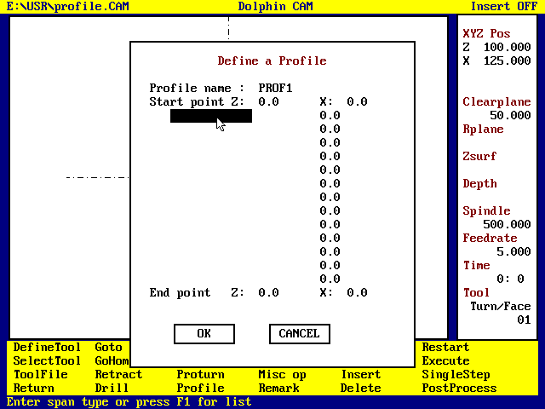
Profile Dialogue
So far all that has been entered is the Profile name , in this case PROF1, which must be unique, and the start point Z and X co-ordinates, both 0.
Following the start point there are a number of fields which have no field names, the first of which is shown selected above. These fields each accept a geometry element e.g. a face or a taper. When a geometry element name is entered a prompt appears for a numeric value to be entered into the field to the right. Allowable geometry elements are :-
Geometry element | Description | Numeric Value
Face | Defines a face in the component | Z position
Diameter | Defines a diameter of the component | X diameter
Fillet | Defines a fillet between a face and a diameter | Radius
Chamfer | Defines a chamfer between a face and a diameter | Fillet depth
Taper | Defines a tapered section of the component | Taper angle
End | Tells DCAM that no more elements will be entered. | None

Pressing the F1 key or the mouse right hand button will reveal a list of acceptable element names which can be selected using the mouse or the and ↓ arrow keys.
There are a few simple rules that must be obeyed in order to achieve a profile definition which is acceptable to the system :-
1. The profile should start at Z0 X0, and end at some negative Z value and X0
2. The first element must be either a FACE or a TAPER.
3. The last element must be END
4. No two consecutive elements can be of the same type.
5. A fillet or a chamfer can only appear between a FACE and a DIAMETER.
6. It is not necessary to define undercuts or other grooves.
7. Don't waste time defining elements that are not going to be machined.
A Component to be defined using PROFILE
To define the component shown above start at Z0X0 and enter the elements :-
1. FACE at Z0.0
2. CHAMFER size 2.0
3. DIAMETER 24.0
4. FACE at -25.0
5. TAPER angle 171.86
and so on ...
As elements are added to the list the dialogue will update the End point Z and X values so that they always contain the last known intersection point - of a face and diameter.
Once all the data have been entered select OK. DCAM will then draw the profile as shown below.
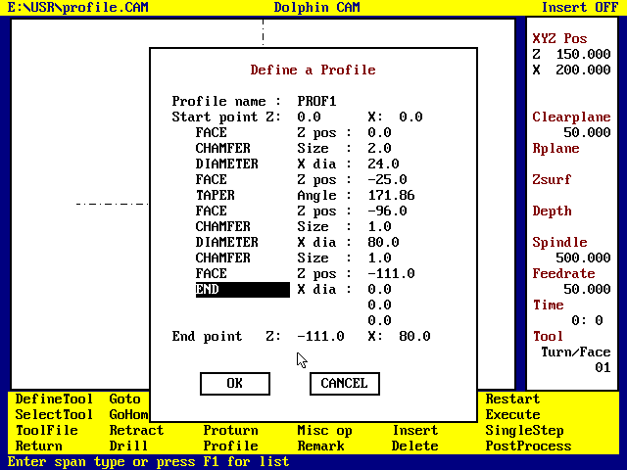Data entered in the PROFILE Dialogue 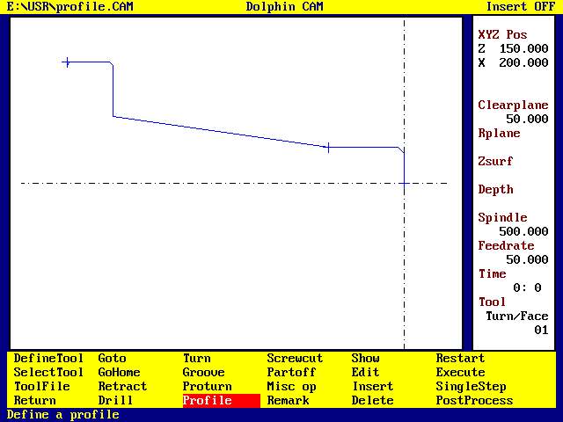The defined PROFILE

Screwcut
Screwcut is a general purpose thread forming cycle for threads cut on parallel or tapered parts.

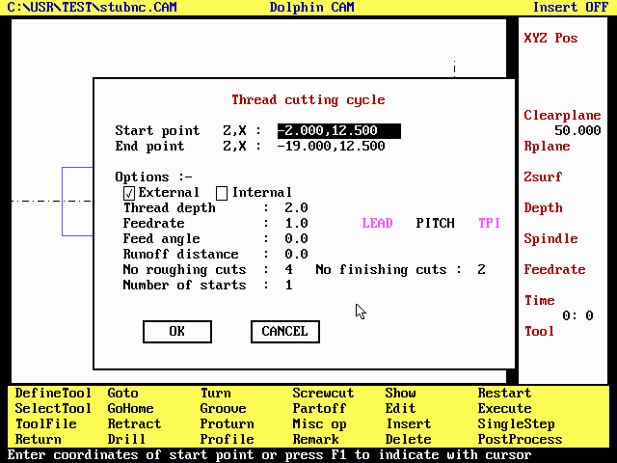Defining a Thread cutting cycle

The screw cutting cycle operates between the start point ZX co-ordinate and the end point ZX co-ordinate. No allowance is made here for the depth of the thread. If these co-ordinates have the same X value, a parallel thread is produced, otherwise a tapered thread is machined.
- External Tick this box to produce male threads.
- Internal Tick this box to produce a female thread. It is the users responsibility to ensure the tool can enter the bore.
Thread depth is the total depth of the thread including roughing and finishing cuts. It is measured radially and is always positive.
Feedrate determines the feed per revolution of the workpiece and may be entered as either the PITCH, the LEAD or the Threads Per Inch of the thread to be cut.
Feed angle is measured positive anti-clockwise from a line parallel to the X axis. A feed angle of 0.0 will cause the tool to cut evenly on both flanks. Setting the feed angle to half the thread tool included angle will cause the tool to cut on one flank only.
Runoff Distance If a non zero runoff distance is entered the tool will be retracted in the X axis while continuing to cut the thread in the Z axis. This value should be about the same value as the thread depth.
Number of roughing cuts Number of finishing cuts The number of roughing cuts and the Number of finishing cuts together determine the total number of passes used to cut the thread. DCAM increments the depth uniformly for each roughing cut and each finishing cut. The increase in depth for all the finishing cuts together is equal to the increase in depth for each roughing cut.
The Number of starts The number of starts can be specified but has no effect on the graphical verification. It does however affect the feedrate and the data sent to the post-processor.

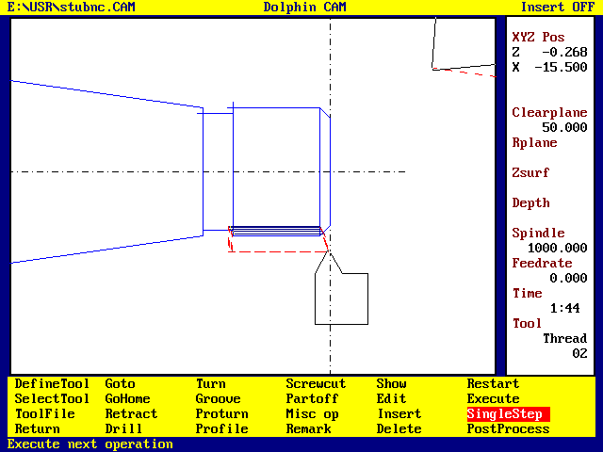A THREAD cutting operation
 Currently DCAM does not directly support the production of left hand internal threads.
 If a thread cycle is output expanded by the post-processor then any compound in-feed move (i.e. feed angle non-zero), the actual threading move and the runoff move, if programmed, are all output using (typically) a G33 command.

Partoff
Partoff initiates a parting off operation using a tool of type GROOVE.

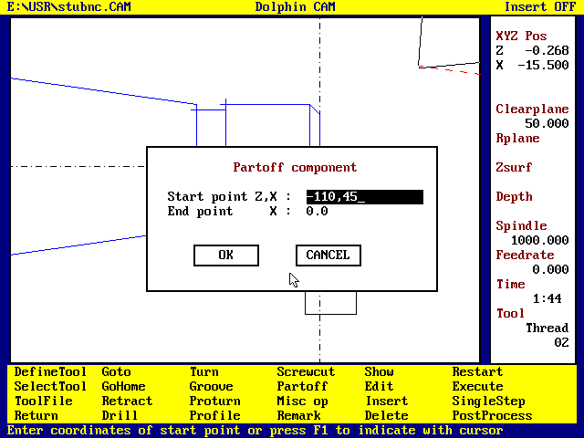
Defining a Parting off operation

When defining the Z co-ordinate it is necessary to consider how the part-off tool was defined.
If the tool was defined so that its datum is on its right hand edge, then the Z co-ordinate to be entered is the actual component length, otherwise if the tool was defined so that its datum is on its left hand edge then the Z co-ordinate must be increased by the width of the part-off tool.

Misc Op (miscellaneous)
This command provides a number of miscellaneous commands which are sent directly to the post-processor, and which do not produce any graphics output.

Command | Description
Stop | Commands the post processor to issue a stop command (M00)
Optional stop | Commands the post processor to issue an optional stop command (M01)
Spindle stop | Commands the post processor to stop the spindle . (M05)
Spindle start | Commands the post processor to restart the spindle . (M03 or M04)
Block skip on | Commands the post processor to start each block of output with the block skip character. (/N001...)
Block skip off | Cancels a preceding Block skip on command.
Part catcher open | Commands the post-processor to output the code required to ready the part catcher to receive a component. (This command is also issued automatically by the Partoff operation)
Part catcher close | Commands the post processor to retract the part catcher.
Coolant ON | Commands the post-processor to switch coolant ON
Coolant OFF | Commands the post-processor to switch coolant OFF
Chuck Open | Commands the post-processor to open the chuck.
Chuck Close | Commands the post processor to close the chuck
Barfeed forward | Commands the post-processor to output code(s) to operate a bar feed / bar puller device.
Barfeed distance | The distance the barfeed device is to move the stock ready to commence machining of the next component.

• If more than one command is "ticked" they are sent to the post-processor in the order shown above.
• The commands may be used (by the post-processor) to execute a whole sequence of commands, for example the Barfeed command may stop the spindle, open the chuck, advance the stock, close the chuck and finally restart the spindle.
• It is not necessary to output Spindle Stop commands prior to a tool change as this is done automatically.( An entry in the DCAM.TXT file can be used to switch this feature ON or OFF)
• The Spindle Start command cannot be used unless a spindle speed has been set using the SelectTool command.
• The post processor may ignore these commands if the machine tool controller does not support the requested command.

Remark
The Remark command is used to enter a remark or comment into the NC program file. Depending on the post-processor to be used it will normally be output enclosed in parentheses e.g. :-
N095 ....
N100 (*MSG : CHECK TOOL FOR WEAR - SET D01 TO COMPENSATE)
N105 ...

Show
Show is used to define how tools and geometry will be drawn, together with viewpoint. Use the mouse to select the desired options - by pointing and pressing the left-hand button.
During graphical verification of a part program drawing the tool centreline only is very fast but may not allow the tool path to be immediately obvious. Animating the tool drawing allows the tool path to be followed quite easily but can take considerably longer especially on SX computers.
Zoom in, Zoom Out (Full window) and Redraw are also available directly from the main menu and are described above.
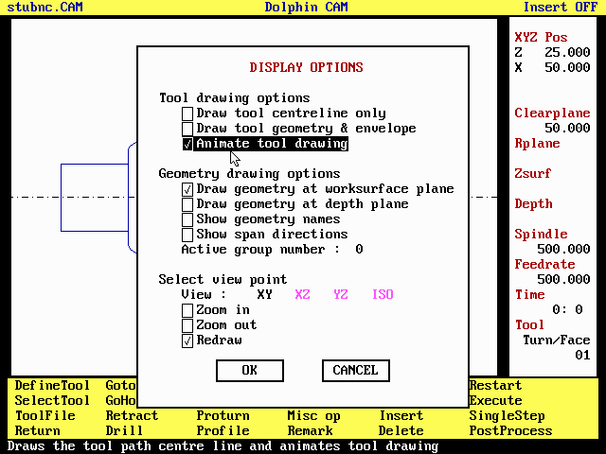Using Show to control the screen display
Some of the options are mutually exclusive, for example ticking Animate tool drawing will remove the tick from either of the other two options under the heading Tool drawing.
Although DCAM permits it, showing the geometry other than in the XY plane is of little use when turning.
After a redraw profiles are drawn symmetrically by mirroring about the Z axis.
If Zoom in, Zoom out and Redraw are all ticked then they are executed in the order Redraw, Zoom out and finally Zoom in.
The Active group number field is not active in turning mode.

Edit
The Edit command is used to modify a command that has been previously defined. A scrolling list of commands in the current program is presented to allow the user to select which is to be modified. Use the mouse left button or the and ↓ arrow keys to select which command is to be edited. Selecting None of them or pressing the ESC key is equivalent to selecting the Cancel button in a dialogue and aborts the command.
Once the operation to be edited has been selected, Dolphin CAM will present the original dialogue box as used to define the operation. The user can now enter new data into the dialogue in order to modify the operation. Selecting the OK button will save the new version while selecting the CANCEL button will restore the old version.
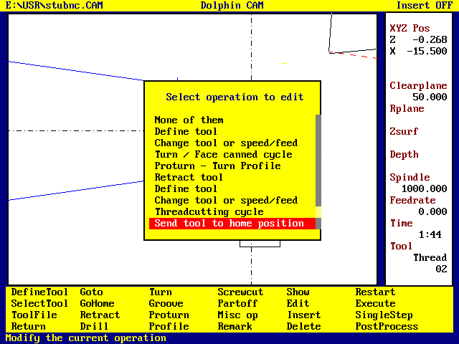Selecting an operation to edit
• Selecting the Cancel button will leave the original operation unchanged, so that Edit can also be used to review the program, operation by operation.
• Selecting Edit will switch Insert Mode to OFF
• After using Edit to modify an operation use SingleStep or Execute to review the effect on the program.
• The data entered into the three Setup dialogues, Part number, Program number, Machine type, Programming units, Tool change position, Origin, Clearance plane and Feed change plane, can be modified at any time, by returning to the main menu and selecting the Setup command. The Machine type cannot be changed in this way nor can the programming units.
• The Setup command cannot be used to insert multiple Origin commands into the program. The data entered into the Setup dialogues is considered to be global to the entire program.
• The Feed change plane can also be changed in any command dialogue which causes Z axis motion e.g. drill or Goround.

Insert
Normally whenever a new command is defined, it gets appended to the end of the machining sequence. In order to insert new commands at some other point use the Insert command to switch Insert ON. A list of existing commands, similar to the Edit list shown above, is presented to allow the user to define at which point new commands are to be inserted into the program.
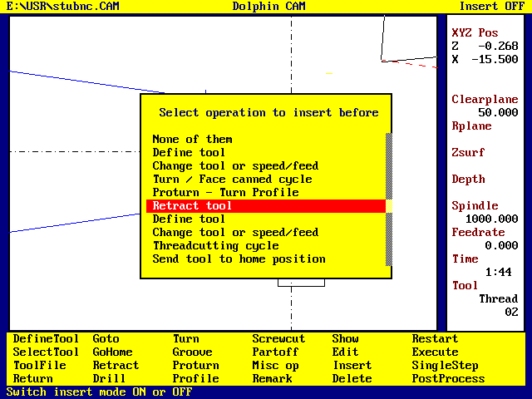Use INSERT to add a new operation before an existing one
• Selecting Insert a second time - or selecting the Edit or Delete commands - will switch Insert mode OFF , and all further commands will be appended to the end of the program until Insert is switched ON once more. The current setting of the Insert Mode is displayed in the top right hand corner of the screen.
• After switching Insert mode ON, new operations are added into the program before the selected operation.
• After inserting commands in the middle of a program use Restart and Execute to review the effect on the program as a whole.
• Selecting None of them or pressing the ESC key cancels the operation and the Insert mode setting remains unchanged.

Delete
The Delete command is used to remove operations from an existing program. It works the same way as the Edit and Insert commands. When selected a list of operations is displayed :-
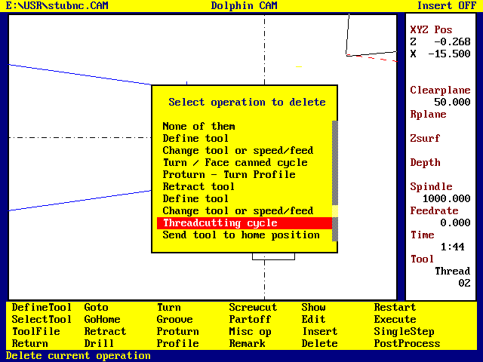Selecting an operation to Delete
Once the operation to be deleted has been selected, its dialogue is displayed, with DELETE and CANCEL buttons, instead of OK and CANCEL buttons. The data in the dialogue cannot be modified. Only the two buttons are significant, selecting the DELETE button will cause the operation to be removed from the program. Selecting Cancel will abandon the delete, and the program will be left unchanged.
• Selecting None of them or pressing the ESC key cancels the Delete command.
• Deleting any operation will switch Insert mode OFF
• After Deleting one or more operations, use Restart and Execute, to review the effect on the program.
• There is no Undelete command, once deleted the command is irretrievably lost.

1 The tool datum point is the point of intersection of a line parallel to Z axis tangent to the tool tip, and a line parallel to X axis, also tangent to the tool tip
2 The primary edge is the one that is cutting when the tool moves towards the chuck in the Z axis.
3 The secondary edge is the one that is cutting when the tool move towards the centreline in X axis.
The tool datum point is the point of intersection of a line parallel to Z axis tangent to the tool tip, and a line parallel to X axis, also tangent to the tool tip.
The tool datum point is the point of intersection of a line parallel to Z axis tangent to the tool tip, and a line parallel to X axis, passing through the centre of the tool tip radius.
Because the tool is symmetrical about the X axis, the Z axis tip offset is zero.
Either edge can be used as the primary edge, provided that the primary and secondary angles are consistent. Normally the primary edge is the one that is cutting when the tool move towards the chuck in the Z axis.
The tool datum point is the point of intersection of a line parallel to Z axis tangent to the tool tip, and a line parallel to X axis, passing through the centre of the tool tip radius. It may be either corner of a square ended tool such as a partoff blade. The button tool can be treated in this way, but is best defined in the same way as an ordinary turning tool with a primary angle of 270° and an included angle of 0°, or if it is symmetrical about Z axis, a primary angle of 0° and an included angle of 0°.
For a partoff blade with the datum at the right hand corner of the tip, the primary angle is 180 and the included angle is set to 90. If the datum is set at the left corner then the primary angle is zero and the included angle is -90.

