Thanks Graeme,

Very efficient and compact code!! However I still have a problem with wild arcs in both your and my programs. See Attached Toolpath images.

The crazy thing is that I have a program that works using a "P" rather than a "D" offset. See example of the Toolpath image and program attached.

I prefer not to use Tool Tables (and any data therein) for 2 reasons:

1. I am a learner and my mill does not use a tool changer (yet) and I use gang tooling on my lathe, and

2. I found that using tool table data on my lathe caused excursions beyond the limits of my cross slide travel so I settled on temporary G52 offsets for each tool in the gang. (Works great)

As a result, all of the data in my tool tables is set to 0. I will use tool tables when I have access to a tool changer.

Whilst fiddling yesterday, I actually saw a correct Toolpath using a "P" offset on the simulation screen in my office. So I closed the file and rushed out to my shed to test the code on the mill computer, only to see the wild arcs again. I went back inside to recheck but the Toolpath had reverted to "wild arcs". So I now suspect that Mach3 has some form of "intermittency".

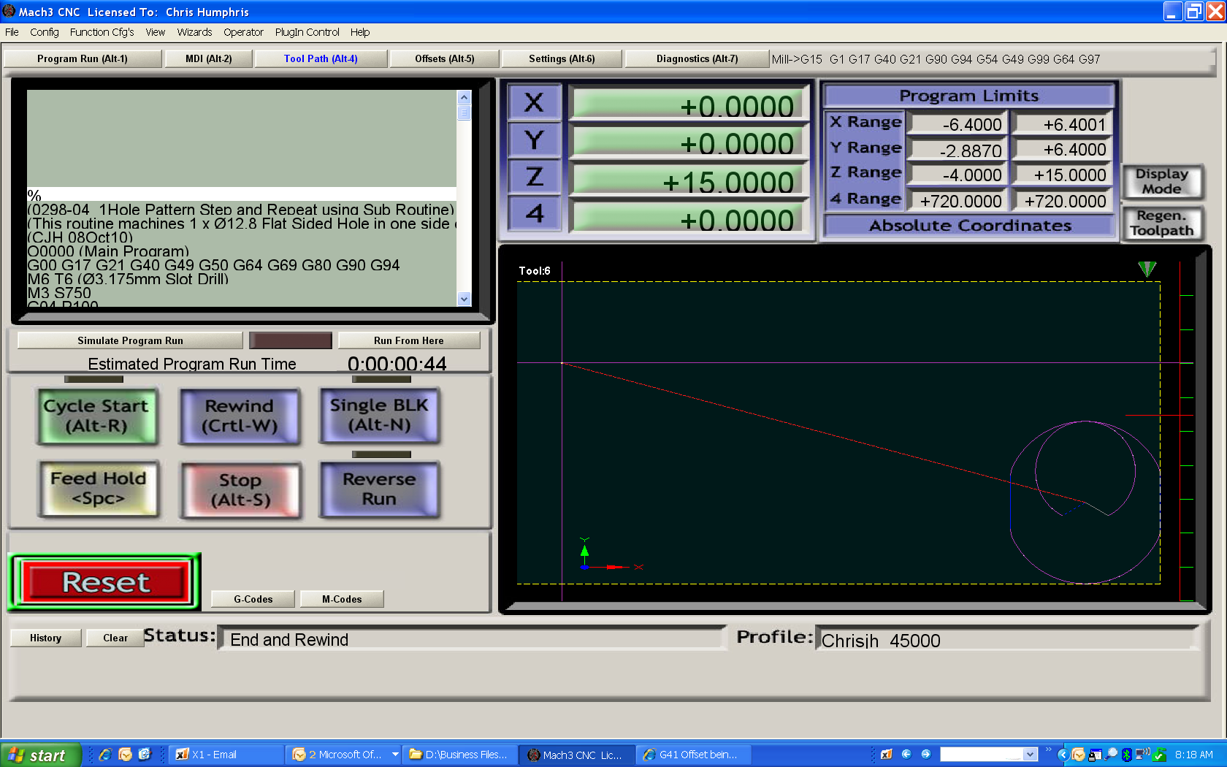
Graeme’s code with D=0
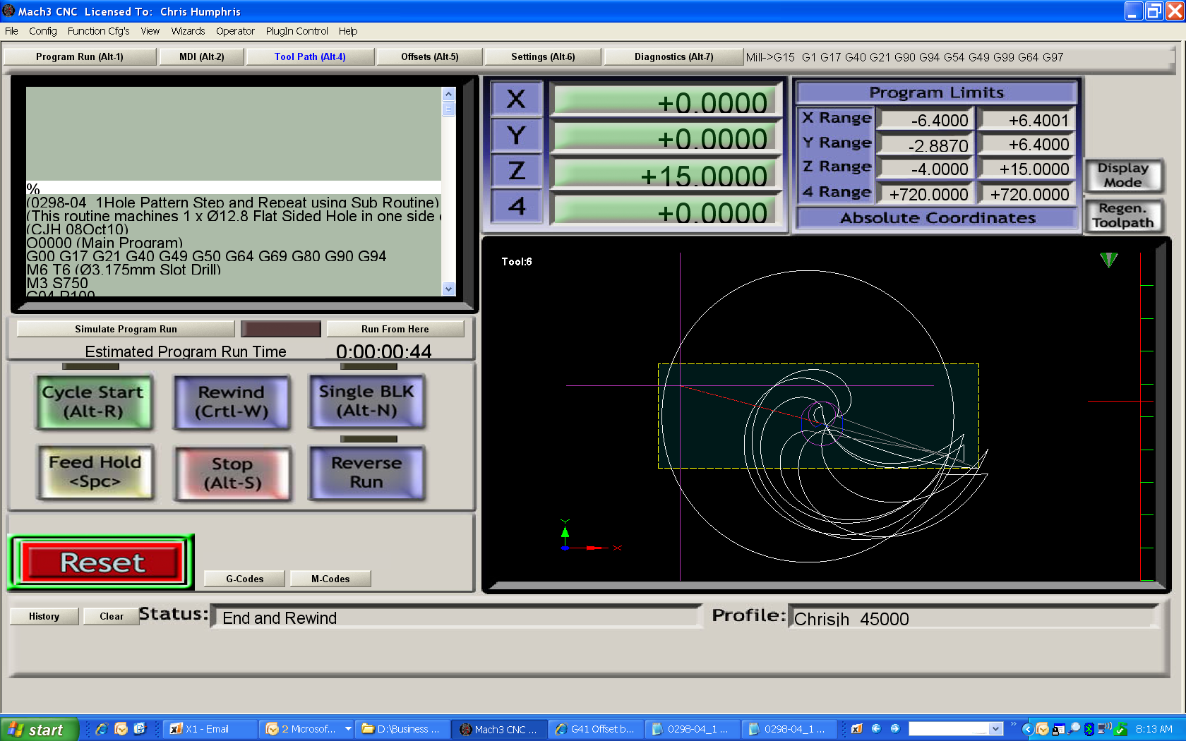
Graeme's code with D offset applied
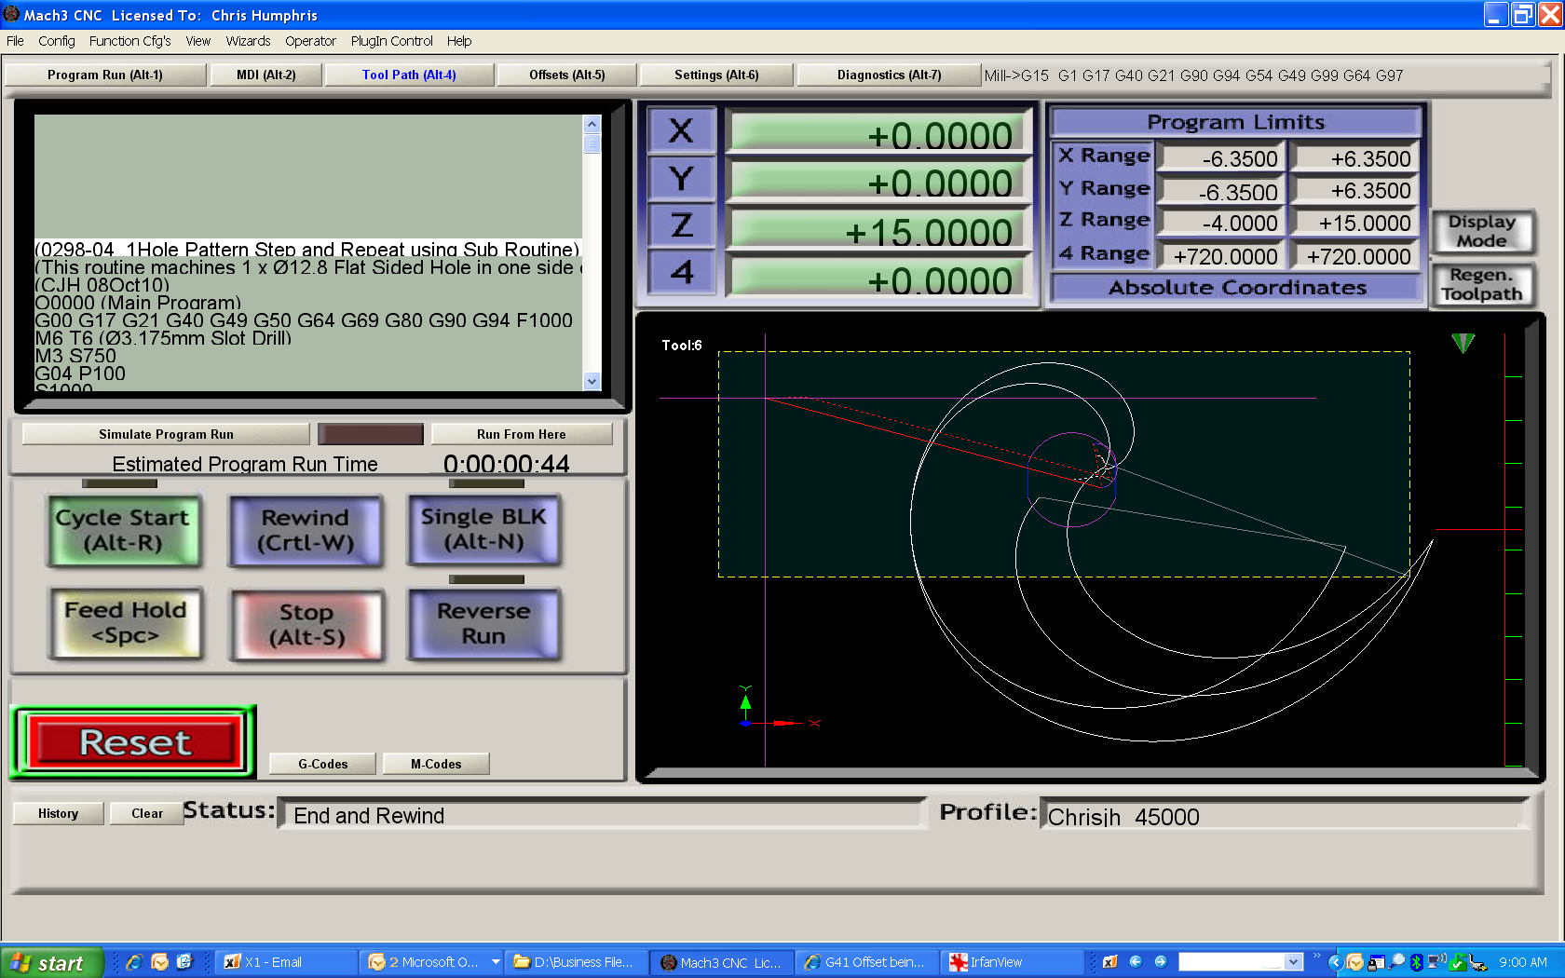
My code with P Offset applied within program
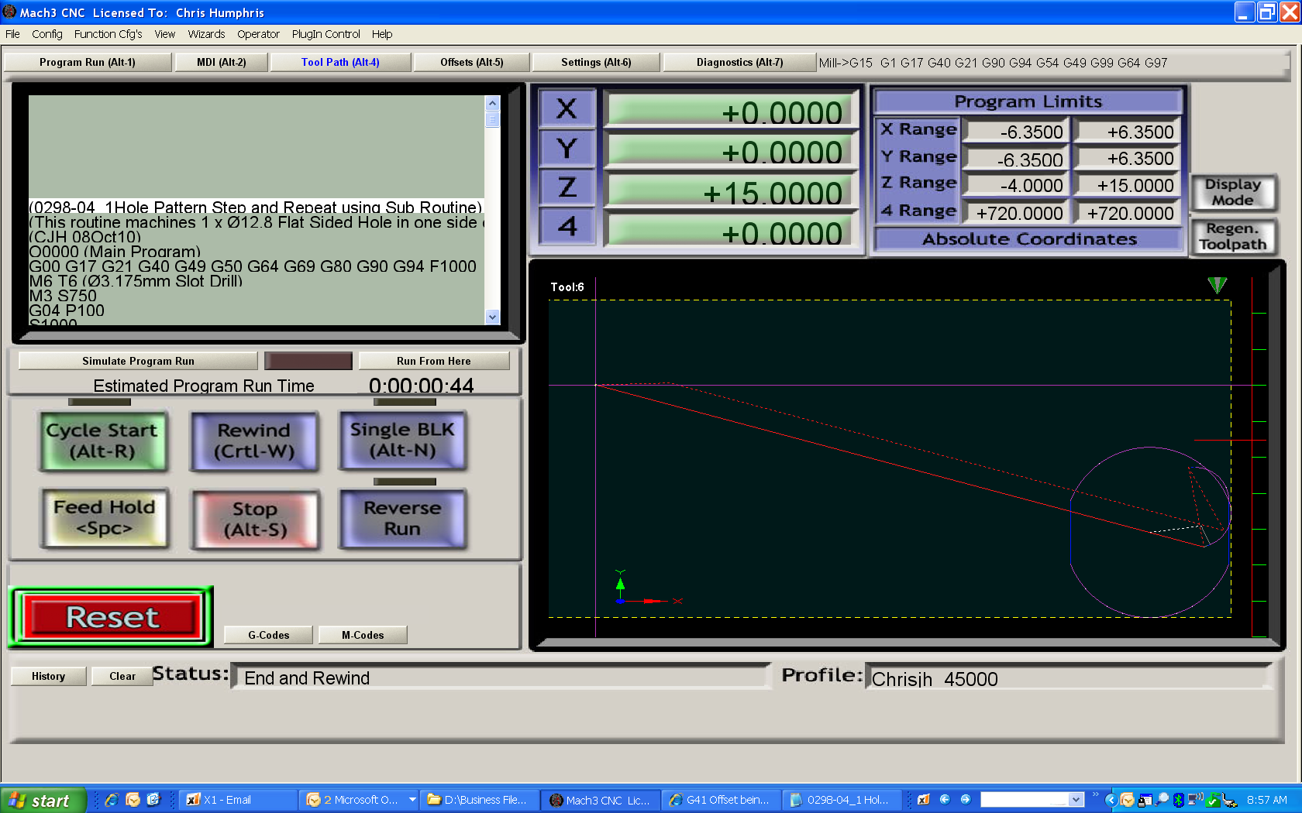
My code where P Offset is ignored
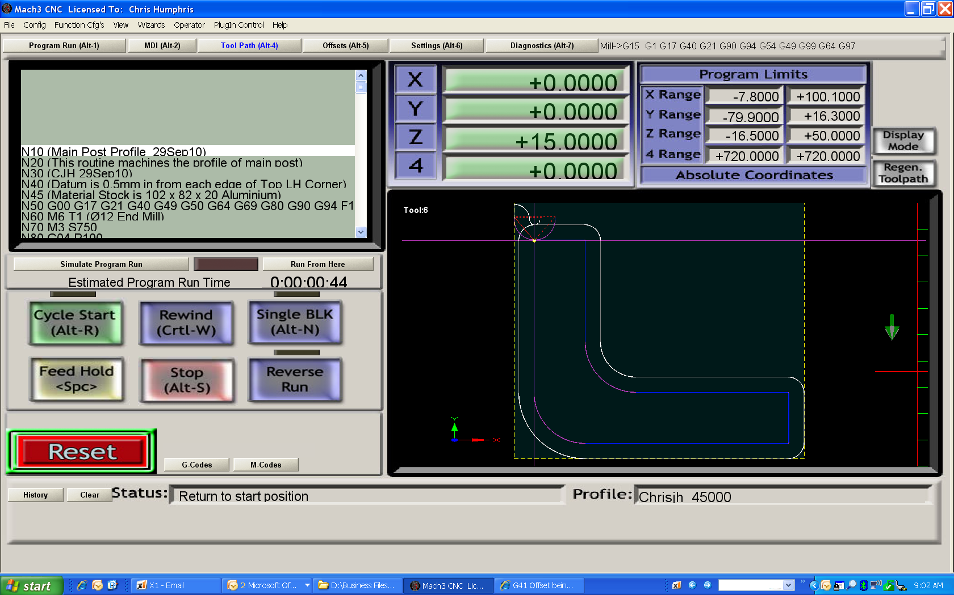
Example of code with P Offset that works

